Department for Environment, Food and Rural Affairs CSG 15
Research and Development

Final Project Report
(Not to be used for LINK projects)
Two hard copies of this form should be returned to:
Research Policy and International Division, Final Reports Unit
DEFRA, Area 301
Cromwell House, Dean Stanley Street, London, SW1P 3JH.
An electronic version should be e-mailed to resreports@defra.gsi.gov.uk

Project title | GROWTH AND COMPETITION MODEL FOR ORGANIC WEED CONTROL

DEFRA project code | OF 0177

Contractor organisation and location | Horticulture Research International  Wellesbourne  Warwickshire  CV35 9EF

Total DEFRA project costs | £ 58,281.00

Project start date | 01/04/99 |  | Project end date | 31/03/02

Executive summary (maximum 2 sides A4)

The project aimed to examine the organic extension of a simple mechanistically-based growth and competition model, calibrated to data originally gained from conventional vegetable production. Essentially the model simulation follows the growth of each crop and weed plant as they compete for space and light during and after canopy closure. The growth and competition model has been modified to simulate crop and weed growth of multiple cohorts so that the onset of crop weed competition can be be predicted. This onset of competition marks the point at which it is essential to remove weeds (i.e. critical weeding time) otherwise there will be a penalty to crop yield.

In organic systems weed control is achieved by a combination of “coarse” control (rotations and stale seedbeds) and “fine” control (mechanical weeding, thermal control and hand weeding). There is always a need for some degree of “fine” control and it represents a significant cost to growers in terms of labour and machinery resources. Failure to control weeds can, at worst, lead to the entire loss of a crop. At best the uncontrolled weeds may not significantly reduce yield, but may cause problems with harvesting, crop quality and seed return if left uncontrolled to harvest. As such, weeds, and the lack of reliability in their control, are still perceived as a major obstacle that needs to be overcome by growers considering conversion. Adding greater confidence and reducing uncertainty from the whole weed control decision making process in organic systems, would be a significant way forward. By targeting the expensive and time-consuming “fine” control, this may help reduce the number of times a grower needs go in to the field to remove weeds. As a result this would reduce costs, improve profitability and ease problems with resource availability. In addition, the repeated soil disturbance caused by frequent mechanical weeding operations may cause as yet unquantified and potentially detrimental effects on soil structure and further stimulation of weed emergence. Reducing the number of weeding operations through better targeting may help minimise potential problems.

Part of the project has been to re-calibrate the model to include onion as an additional crop species. As seen in other crop and weed species, a power relation was observed for onions between total plant leaf area and total plant dry weight. However, in onions this power relation was found to be different over time because of leaf senescence above ground as the bulbs started to develop. An equation for the growth rate of the onions was therefore developed including a senescence parameter and using observations of leaf area, crown zone area and ground cover data for well-spaced plants. The relevant parameters were then calculated to allow the inclusion of onion within the model.

The model, once parameterised for a given species, can be applied to determine the onset of competition between competing species (i.e. crop and weed). In organic crops this would be the time when physical removal of the weeds (either by means of mechanical or hand weeding methods) was essential to prevent yield loss. To test the ability of the model to identify critical weeding times, model predictions were compared with historical experimental data. The inputs to the model are starting plant weights and the numbers of individuals per unit area of the crop and weed species for each cohort at each day of the simulation. For the onion and cabbage crops, the inputs are relatively simple since they are transplanted and represent a single cohort. For a crop such as carrots the seedling emergence cohorts were determined, as for the weeds, from early observations of seedling emergence. Solar radiation was used to drive the model. All the growth parameters were species specific and where a number of weed species are competing with the crop in a mixed population, then a general set of parameters representing the mean of a range of parameterised weed species were used. Repeatedly running the simulation with different starting inputs from a range of historical data sets indicated that the observed critical weeding time was described well by the model.

To examine the applicability of the principle of the growth model to an organic cropping situation, the predicted optimum timing of weed removal simulated by the model was incorporated as a treatment into an existing organic carrot trial. The aim was to see whether the weeding time simulated by the model achieved comparable or better results than the weeding by the unaided judgement of the grower. Could therefore the simulation model provide potential backup to the growers decision making process? Early assessments showed that there was an initial positive impact on the crop weight, however this head start did not significantly effect the final yields at harvest. The typically late sowing of carrots to avoid carrot fly, coupled with poor coverage of the indigenous weed flora masked potential greater differences in the outcome from the different weed timings. However, the results demonstrated that there was certainly no disadvantage to using the model in that year to aid in the decision making process.

Finally, to test the application of the growth and competition model to other related species, a small-scale trial was made in year 3. The trial included cabbage plus three previously unparameterised crops; broccoli, cauliflower and leeks. The crop parameters for cabbage were used to drive the cauliflower and broccoli simulations and onion parameters for leeks. Three treatment were; weeding once as recommended by advisors at HDRA, weeding once as predicted by the model and left weedy throughout to test the competitive level of the weed flora. Inputs into the model were solar radiation, crop transplant weights and numbers (which were adjusted specifically to account for the wider spacings in organic systems to allow access for weeding machinery) and weed weights and numbers during the early weeks of crop growth. Initial model simulations suggested a much later weeding time than was made for the standard weeding treatment (24 July), and that there would be no onset of competition until mid-August at the earliest. Only when the final crop harvest data was available and data had been collected later in the season from the weed flora, could the final comparisons be made. Adjustment of the model using the final crop weights was necessary. This empirical adjustment was thought to be related to the different relative growth rates of the crops in organic soils, compared with the higher N levels in conventional soils from where the parameters had been originally derived. After recalibration, the model re-confirmed the mid-August onset of competition, but tended to over predict the degree of weed competition. The notable exception was the leek crop which was more sensitive to competition than its brassica counterparts and gave a good illustration of the potential power of the model.

As part of the project several presentations have been made to growers during the final year, which have allowed a dialogue and awareness to develop highlighting the practical and scientific implications of the model. The project has illustrated the potential for the model to demonstrate the critical weeding time. However there is now a practical need for inclusion of factors such as weeding machinery efficacy relative to crop and weed growth stage, reliable weed inputs available earlier in crop development and importantly, the need to identify the robustness and biological cause of the necessary correction factor.

Scientific report (maximum 20 sides A4)

- INTRODUCTION AND POLICY RATIONALE

In organic systems, weed control is achieved by the combination of two broad strategies. Firstly, ‘coarse control’, which includes use of crop rotations and stale seed beds to keep the weed populations and weed seed soil bank as low as possible. Secondly, ‘fine control’, which involves direct physical and thermal control and in high value crops the use of hand labour to eradicate weeds within the crop. Even the best ‘coarse control’ cannot prevent some weeds from emerging in the crop, so there is always a need for some degree of ‘fine control’. Failure to control weeds can lead to the entire loss of a crop. These ‘fine control’ measures are expensive. For organic carrot and onion crops, 150 to 200 man-hours per hectare are required for weed control measures, which can account for 15 to 30% of the variable costs of production. Targeting the ‘fine control’ measures more accurately would: -

- increase the profitability of organic vegetable production
- reduce management problems in supply of machinery and labour
- allow more crop rotation combinations to be applied
- encourage conventional growers to adopt organic practices
- reduce the obstacles for conventional growers to convert to organic production

- PROJECT OBJECTIVES

The purpose of this project is to illustrate the potential for using optimal times for weed control in organic vegetable production by adopting a general mechanistically-based model, calibrated to data gained from conventional vegetable production. This will reduce the costs of production, increase yields and quality and encourage the growers of conventional vegetables to adopt organic practices. The agreed project aims have therefore been to:

- To calibrate fully the growth and competition model for onions
- To use the model to determine the optimal mechanical weeding times in cabbage, carrot and onion
- To validate the model using historical and new experimental data
- To test that the predictions of the model can be extended to other related species
- Inform organic growers of the results of the model simulations

PROJECT RESULTS

3.1 To calibrate fully the growth and competition model for onions

As observed in other crop and weed species (Park et al, 2001), a power relation was observed in onions between total plant leaf area, a_{l}, and total plant dry weight, w. That is:-

$$\text{ln}a_{l}=\text{-5}\text{.}\text{5188}+0\text{.}\text{9157}\text{.}\text{ln w}$$ | (1)

Onions were found to be exceptional because these power relations broke down for older (larger) plants. Consequently, the parameters of the power relation were determined in a set of well spaced plants that were less than 25 g total plant dry weight.

To estimate the leaf area of older plants, it was assumed that the breakdown of the power relation occurs at the onset of partition of dry matter to the bulbs. This was defined as the day of the year in which the ratio of leaf plus pseudo stem to bulb dry weight, r_{b}, exceeds 1.2:1(Mondal et al., 1986a). Using a regression of the log of r_{b} against day of the year,
r_{b} was estimated to achieve a value of 1.2 on day 190.

The rate of leaf senescence was then assumed to be determined by the duration of bulb growth, which is a function of percentage light interception, I%, and mean daily temperature, T, (Brewster et al., 1986). Inverting the Brewster et al., (1986) equation gives a daily rate of senescence, s :-

$$s=1(\text{104}\text{.}\text{8-0}\text{.}\text{245}\text{.}\text{I\%-2}\text{.}\text{714}\text{.}T)$$ | (2)

where
$$I\text{\%}=\text{85}\text{.}\text{42}(1−\text{exp}(−k\text{.}L))$$ | (3)

where L is the leaf area index. The leaf area index, L, is given by the ratio of a_{l} to crown zone area, a_{z}. Hence,

$$L=a_{l}/a_{z}$$ | (4)

Hence, after day 190 there is a daily loss of an s^{th} of the leaf area that had been accumulated by the time of the onset of partitioning of dry matter to the bulb.

Crown zone area a_{z} also has a power relation with w.

$$\text{ln}a_{z}=\text{-3}\text{.}\text{0377}+0\text{.}\text{5609}\text{.}\text{ln w}$$ | (5)

Plants with a dry weight of over 25 g had a constant a_{z} value of 0.2634 m².

The growth rate of each plant is given by:-

$$\text{dw}\text{dt}=b\text{.}I\text{.}a_{z}\text{.}(1−\text{exp}(−k\text{.}L))$$ | (6)

The value of the extinction coefficient, k, was estimated to be 0.6790 from observations of the leaf area, crown zone area and ground cover data for the well-spaced plants.

The remaining unknown parameter, b, which is the conversion of light to dry matter, was estimated by fitting eqn(6) to the dry weights of the well-spaced plants. The mean weight observed at the first harvest was used as an initial weight. The numerical integration used the 4th order Runge-Kutta method with a fixed step length of 1 day. The daily mean temperatures were calculated assuming that (i) the minimum temperature was at sunrise; (ii) during the hours of daylight the change in temperature with time can be described by the upper part of a sine curve; (iii) there is an exponential decrease in temperature between sunset to sunrise, (Parton and Logan, 1981; Reicosky et al., 1989). The duration of sunlit hours was calculated according to the latitude and day of the year.

The value of b was estimated by least squares non-linear minimisation as 1.88 g dm MJ⁻¹.

  - To use the model to determine the optimal mechanical weeding times in cabbage, carrot and onion

In order to determine the optimal weeding times, it is necessary to use eqn (6) in combination with a set of rules that determines the value of a_{z} for each plant during and after canopy closure. The simulation must follow the growth of each crop and weed plant, allowing for the contest of space amongst crop plants, weed plants and between crop with weed plants.

For historic data sets from weeding experiments, the crop and weed species are each considered as a set of dates of seedling emergence cohorts. Where seedling emergence had not been recorded, then the numbers emerging each day were estimated by assuming that the emergence patterns were from a log-Normal distribution in time. Onion and cabbage crops were transplanted, so consisted of a single cohort. For carrots, the seedling emergence cohorts were determined as for weeds, from observations of seedling emergence. Where carrot seedling emergence had not been observed, then the Finch-Savage (1998) model for seedling emergence was used to estimate the numbers of carrot seedlings emerging on specific days.

Figure 1. The observed (symbols) and predicted “free growth” (shown by the line) of isolated plants of cabbage (shown in orange) and nightshade (shown in green) using the growth model. The model predicts growth on a daily basis.

In the simulation of crop and weed growth, a time step of a single day was used. For each new time step, a cohort of crop and weed seedlings was created. The numbers of crop and weed plants in each cohort were predicted from the seedling emergence data or from the seedling emergence model. The weight of each newly emerged seedling was based on observations of crop or weed weights taken shortly after emergence. The MATLAB program held the mean plant weights and numbers per unit of area of the crop and weed species for each cohort at each day of the simulation. The growth rate of crop and weeds on each day was calculated by inputting the information from the data matrix to a population procedure to simulate the contest for space between the different age and species cohorts. All the growth parameters of the model are species specific. These were estimated from isolated plants and examples of this “free growth” as predicted by the model are demonstrated for both a crop and weed species in Figure 1. For the crops, the relevant species specific parameters values were used (see Park et al., 2001 for B. oleracea and section 3.1 in this report for onion). For the weed population, a general set of parameter values were used (see Park et al., 2001), which were the means of those for nightshade, chickweed, speedwell and clover.

By repeated running of the simulation to mimic the weeding regimes in critical weeding period experiments, it is possible to predict the optimal weeding windows. To obtain observations of optimal weeding times, data was used from experiments where weeds had been removed from crops after a range of specified times (usually at weekly intervals). The final harvest yields of the crops were compared folowing the different weeding times. The largest crop yields coresponded with the optimal timing of weed removal. There is considerable experiment-to-experiment variation in the observed optimal weeding time and this is described well by the predictions made by the model (Figure 2).

Figure 2. Different symbols represent the observed plotted against the predicted optimal weeding times for a range of carrot trials to illustrate variability in absolute timing between trials, but consistency between observed and predicted optimal timing in a given trial. If there were a perfect agreement between the observed and predicted weeding times then all points would lie on the 45^{O} line.

  - To validate the model using historical and new experimental data

In order to validate the application of the growth and competition model, it was included as an additional treatment within a weed control trial in organic carrots. Data from historical experiments were used to test weed control timings and generate predictions for the new trial. The data suggested that, given typical conditions, the critical weeding period would be between 30 to 45 days after sowing. These were included as the twice-weeded plots at 3 and 5 weeks after 50% carrot emergence.

Experimental protocol

The trial was a randomised replicated block design. There were 14 treatments per block, replicated 4 times producing 56 plots. The trial site occupied a 70 m length and 8 standard 1.83 m bed widths of a commercial carrot crop. Each plot measured 10 m by 1 bed (1.83 m) width. Each 10-m plot had a 0.5 m guard length at each end. This gave a 1-m guard zone between plots to allow for cultivation and weeding equipment to be lifted and lowered between treatments. The 9-m plot was then divided into a destructive assessment area of 3.0 m and a weed assessment/harvest area of 6.0 m. The carrots were grown on a 4-row 1.83 m bed system with 30 cm between the rows.

Treatments included three timings of weed control (once at 3 weeks after 50% emergence, once 5 weeks after 50% emergence and according to the model prediction: weed free period between 3 weeks and 5 weeks after 50% emergence methods). For the model, historical weed emergence data from the trial area were used to drive the model and generate the timing predictions. Four different methods of weed control were used (brush weeded, brush weeded and hand weeded in the crop rows, steerage hoed, steerage hoed and hand weeded in the crop rows) and finally two control plots were included to show the impact of weed free throughout versus left completely unweeded throughout.

Fifty-six 1-m sample lengths of row were marked out, one per plot over the trial area. Crop emergence from these 1-m lengths was recorded on a daily basis until a constant number of carrot seedlings were attained. From these data, a date for 50% emergence was obtained. Treatment dates were calculated in weeks after 50% emergence. The dates for the weedings at 3 and 5 weeks after 50% carrot emergence were 4 July and 19 July 2000 respectively.

3.3.2 Results

Total ground coverage reached a maximum of 21% in the unweeded plots by the end of the season. Following all weedings the percentage ground cover was always lowest in plots which had been weeded twice (i.e. according to the prediction made by the growth and competition model), but not significantly lower suggesting the single weeding was as effective in this particular season. Two weeks after the weeding operations the destructive assessments showed an initial positive impact of the model weeding treatment on individual carrot root weight, but this head start did not significantly affect yields at harvest (figure 3). Weight of carrots per 12 m harvested row ranged from 30763g on the weed free plots to 24050g on the unweeded plots (SED 1834.1). Final carrot harvest weights for each 12 m row was 29212 g, 30089 g and 30038 g (SED 917) for the 3 week, 5 week and model weeded treatments respectively.

Figure 3. The marketable yield of carrots (t/ha) following weeding at 5 weeks, weeding at 3 weeks, weeding at the time predicted by the model, keeping weed free throughout or leaving unweeded throughout.

3.3.3 Discussion

The typically late sowing of organic carrots to avoid carrot fly has a positive impact on weed control and the main flush of spring germinating weeds is avoided. This, coupled with ideal weather conditions for control during the trial season, produced a poor coverage of indigenous weed flora on which to test the factors of weed control being investigated. The results produced were typical of a low weed pressure situation or dry season and can form the basis of recommendations for such scenarios. Where weed pressure is low it can be seen that an intensive weeding programme has little benefit and unlikely to be cost effective. For example, one weed operation may be sufficient to avoid crop losses due to weeds rather than doubling the costs of mechanical weeding by performing a weeding operation twice. This trial demonstrated that, if cultural measures are employed effectively, one mechanical operation is sufficient to control weeds and correct timing is possible. Using guidance from the proposed growth and competition model may help to target that timing effectively.

3.4 To test that the predictions of the model can be extended to other related species.

In order to test the application of the growth and competition model and further examine its application to organic systems a field trial was made during the final year of the project.

    - Experimental protocol

The trial was a randomised block design with four replicates and the trial site was situated on the certified organic land at HRI Wellesbourne (Hunts Mill site) with standard 1.83-m bed widths. Each plot measured 9 m by 1 bed (1.83 m) width. Four crops were included for testing including leeks (cv. Jolant), broccoli (cv. Triathlon), cauliflower (cv. Fargo F1) and cabbage (cv. Wirosa). Cabbage was included to monitor the ability of the model to simulate growth of a crop whose parameters had previously been estimated in conventional systems. The additional, three new crop species were included to measure how well the known crop parameters could be applied to crops of comparable architecture. The growth parameters for cabbage were applied to broccoli and cauliflower, whilst those derived for onion were used to drive the leek simulations. Three treatments were included; 1) to weed once according to normal practice (24 July 2001 as advised by HDRA after field observations had been made), 2) to weed once according to the time predicted by the growth model (16 August 2001) and 3) to leave weedy throughout to measure the competitive level of the background weed flora.

The organic transplants were planted on 26 June 2001 with spacing of the cabbages, cauliflower, broccoli and leeks in accordance with organic recommendations (50cm x 50cm, 50cm x 60cm, 50cm x 40cm and 50cm x 13cm respectively). Transplant plant dry weights of all four crop species were taken at the start of the trial (0.302g, 0.277g, 0233g and 0.257g for broccoli, leeks, cabbage and cauliflower respectively) which were used as the crop starting point for the model. To ensure that soil moisture was not a limiting factor, the site was irrigated throughout dry periods. The broccoli, cauliflower, leeks and cabbage were harvested on the 4 September, 2 October, 30 October and 4 December 2001, respectively. An intermediate crop harvest was taken on the 24 July to monitor crop growth and for testing the crop development alongside the growth model predictions. At crop harvest dry weights, fresh weights and appropriate measures of crop quality were taken. These quality measurements included head/curd diameter, trimmed head fresh weight and visual quality score for cabbage, cauliflower and broccoli. For leeks the trimmed length, blanched length and diameter were measured.

The unweeded plots had 0.5 m x 1m fixed quadrats to monitor weekly weed emergence throughout and take destructive harvests of weed biomass at selected times during the season for comparison with the model simulations. On the 31 July, after the major flush of weeds had ceased, weed material was harvested to provide a detailed measure of the weed flora in terms of species composition, numbers and dry weights for the individual species. The weed biomass and numbers at this point provided the starting values for the growth and competition model, since the flora was considered to have stabilised by this time. As described in section 3.2, a mean weed parameter was used to represent the mixed species weed flora. The crop spacing in the model was adjusted to account for the wider spacings in organic systems to allow for the use of weeding machinery.

    - Results

General observations
During 2001 once again there was a relatively low weed pressure on the organic site at HRI Wellesbourne, resulting in a poor coverage of indigenous weed flora on which to fully test the model. The major weed species was Lolium perenne with Veronica persica and to a lesser extent Stellaria media, Chenopodium album and Tripleurospermum inodorum also being present. By the 31 July the typical flush of weeds that follows crop sowing ceased and weed density had reached approx. 91 plants m⁻² (figure 4).

Figure 4. Mean weekly weed emergence counts (plants m⁻²) made on the organic trial area throughout the duration of the study. The arrow indicates the point at which the major post-seedbed preparation flush of weed emergence ceased.

No significant effect of the three different weeding treatments were observed for the four test crops, however there was a general tendency for the later-weeded plots, as suggested by the model, to have higher yields. Mean head fresh weights also had a tendency to be slightly higher for the model weeded treatments. However only for the mean head diameter of the broccoli was a significant increase (P<0.05) noted for the model weeded plots (189 mm for the model weeded plots compared with 180 mm for the standard weeding and 135 mm for the weedy plots). The leeks showed the most noticeable differences in terms of quality with a tendency for longer trimmed length and blanched length resulting from the model weeded plots and also a significantly lower proportion of unmarketable leeks when graded by their diameter (P<0.05).

Model simulation and calibration
The model was run for each crop species separately (Figures 5,6,7 and 8) using the weed inputs from the 31 July 2001 and crop transplant weights from the 26 June 2001. Crop parameters depended on the crop being simulated (onion parameters for leek and cabbage parameters for broccoli and cauliflower). Solar radiation data were used to drive the growth of the crops and weeds. The heaviest observed final harvest weight was used as an “anchor point” for each of the four crop model simulations on which to base a simple empirical adjustment factor from conventional to organic. This adjustment factor was 0.56, 0.74, 0.58 and 0.97 for cabbage, broccoli, cauliflower and leeks respectively. Using this adjustment factor, the check point mid-harvest weights appeared to fit reasonably well for each species and the predicted competitive growth (i.e. unweeded) diverge from the free growth (i.e. isolated plants) around mid-August. This date was earlier for some crops and slightly later for others, hence 16 August proved to be a sensible point at which to make the weeding treatment as simulated by the model.

Figure 5. The observed and model simulated growth of organic broccoli during the 2001 trial. Previously derived parameters for cabbage were used to drive the growth model for broccoli.

Figure 6. The observed and model simulated growth of organic cabbage during the 2001 trial.

Figure 7. The observed and model simulated growth of organic cauliflower during the 2001 trial. Previously derived parameters for cabbage were used to drive the growth model for cauliflower.

Figure 8. The observed and model simulated growth of organic leeks during the 2001 trial. Previously derived parameters for onion were used to drive the growth model for leeks.

It is striking that in all cases with the weed flora on the given site and in the 2001 season, the model predicted a long period before competition begun (i.e. where the free growth and competitive growth curves diverge, Figures 5 to 8). The weeding treatment according to organic advice was therefore premature and could have been delayed by several more weeks before it would have been necessary in terms of the start of potential yield loss. However, the model went on to over-predict the yield loss at harvest, which for most species (Figure 5 & 6) was not observed. Most notably in leeks (Figure 8) there was a much closer correlation between the predicted and observed competitive growth of the crop, possibly because the leeks were more sensitive to competition than their brassica counterparts.

3.4.3 Discussion

Six major conclusions could be draw from the field observations and model predictions:

- The model adjustment factor and the use of the previously derived cabbage and onion parameters to drive the related crop species, appeared to produce reasonable simulations of crop growth with comparable mid-season crop weights. The simulation indicated that competition started between the second and third week of August depending on the crop. In particular, the simulated and observed competitive growth for cauliflower and leeks were comparable. This adjustment factor is presently only a simple empirical adjustment based on final yield information which is obviously not obtainable in a real cropping situation where a simulation would ideally need to be run in advance if used as a planning tool. Clearly there is a need to see how well the recalibration factors identified in this trial apply to other seasons with a more typical and aggressive weed flora. It is also necessary to identify what this recalibration factor represents biologically. It is likely that it relates to the different relative growth rates of the crops resulting from the lower nitrogen status of the soil. However, further investigations beyond the scope of the present project are necessary to test this hypothesis.

- In all cases, even with the adjustment factor, competitive growth was consistently overestimated for all four crops leading to higher observed yields than were predicted by the model when the weeds were left throughout the season. This may have been the result of three factors. Firstly, the use of a mean parameter to represent the mixed species weed flora may have lead to a more competitive weed flora than if each species had been parameterised separately. However, it would not necessarily be practical to do this except to test whether the validity of the assumption is sound. Secondly, as with crop growth, the weed growth parameters developed from conventional systems may have lead to faster and potentially more aggressive growth than was actually occurring in the lower nitrogen status of the organic system. Thirdy, we assumed that the population denisty of the weeds remained as it was on the 31 July. In fact we know from the observed data that it was considerably reduced by 4 September in a way that was consistent with competition.

- Indeed, in this particular season and with the low-weed-pressure, there was generally little to be gained from weeding in terms of purely crop yield, particularly for the brassica crops. However, despite the over-prediction of competition by the growth model, it clearly illustrates the principle of there being potential flexibility in the timing of the weeding operation. All crops demonstrated both in the simulated and observed yields that this particular weed flora could have been left in the crop longer than 24 July when they were removed according to organic best practice. The less competitive leek crop provided the best illustration of this principle since the model gave a comparable estimate of the final yield results for both the simulated competitive growth and the equivalent observed unweeded plots (Figure 8).

- A major consideration is ease of weeding. For the earlier weeding treatment on the 24 July a steerage hoe with finger weeders (Plate 1) was used directly followed by hand rouging in the rows to remove weeds that had been missed mechanically (Plate 2). Whilst the model simulation supports the observed evidence that the later weeding on the 16 August was not detrimental and in some cases even tended towards better final yields, the weeding operation itself was more difficult. This was because on the 16 August the weed flora had grown and the crop canopy had closed to such an extent that it was impossible to steer through the same machinery and effectively remove the better-rooted weeds without damaging the crop at the same time. For this reason this later weeding treatment necessitated the use of hand labour. This is a serious economical and resource management consideration that would need to be incorporated and costed into any decision support arising from the use of such a model.

- Yield loss should not be the only consideration from the trial. Although the weed flora may not have been detrimental to crop yield in the study year, it is not acceptable to omit weed control. Weed seed return and harvesting difficulties may result from weed left up to harvest; in addition, the relatively small yield differences, for example with the cabbage, may translate to significant economic differences when the costs of harvesting and crop cleaning (to remove weed seeds and weed material contamination) are also considered. Therefore such growth and competition models may be usefully employed not only for growth simulations to target weed timing but also to provide input to drive economic analyses.

Plate 1.(left) Weeding broccoli at standard timing (24 July 2001) using a combined finger weeder and steerage hoe.

Plate 2. (right) Hand weeding leeks within crop rows following mechanical weeding (24 July 2001).

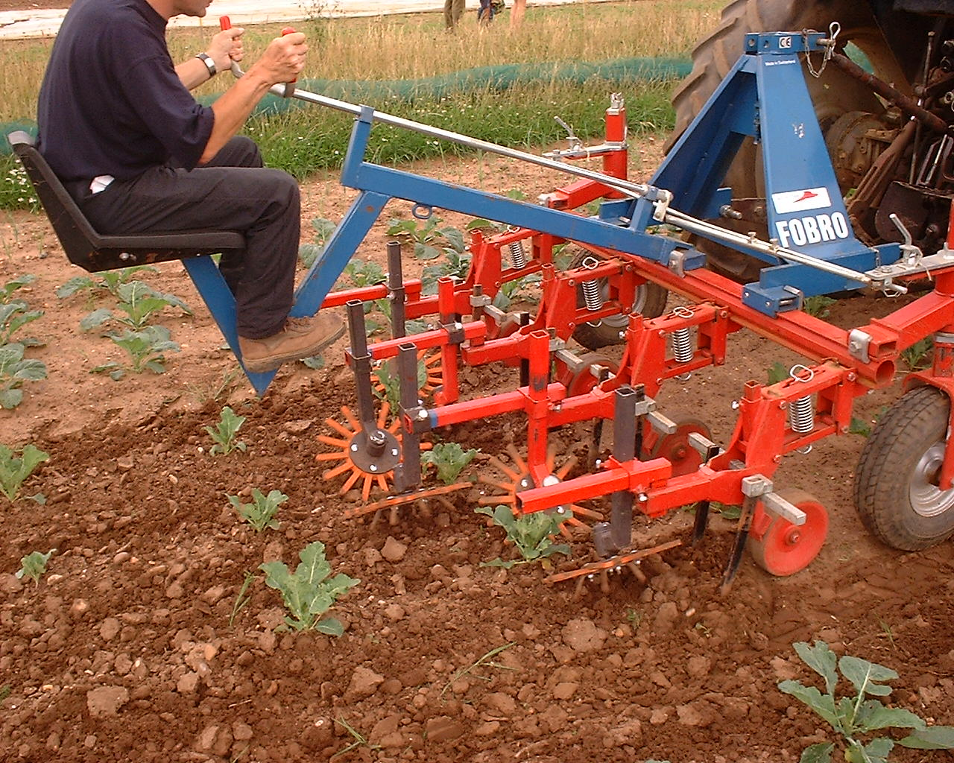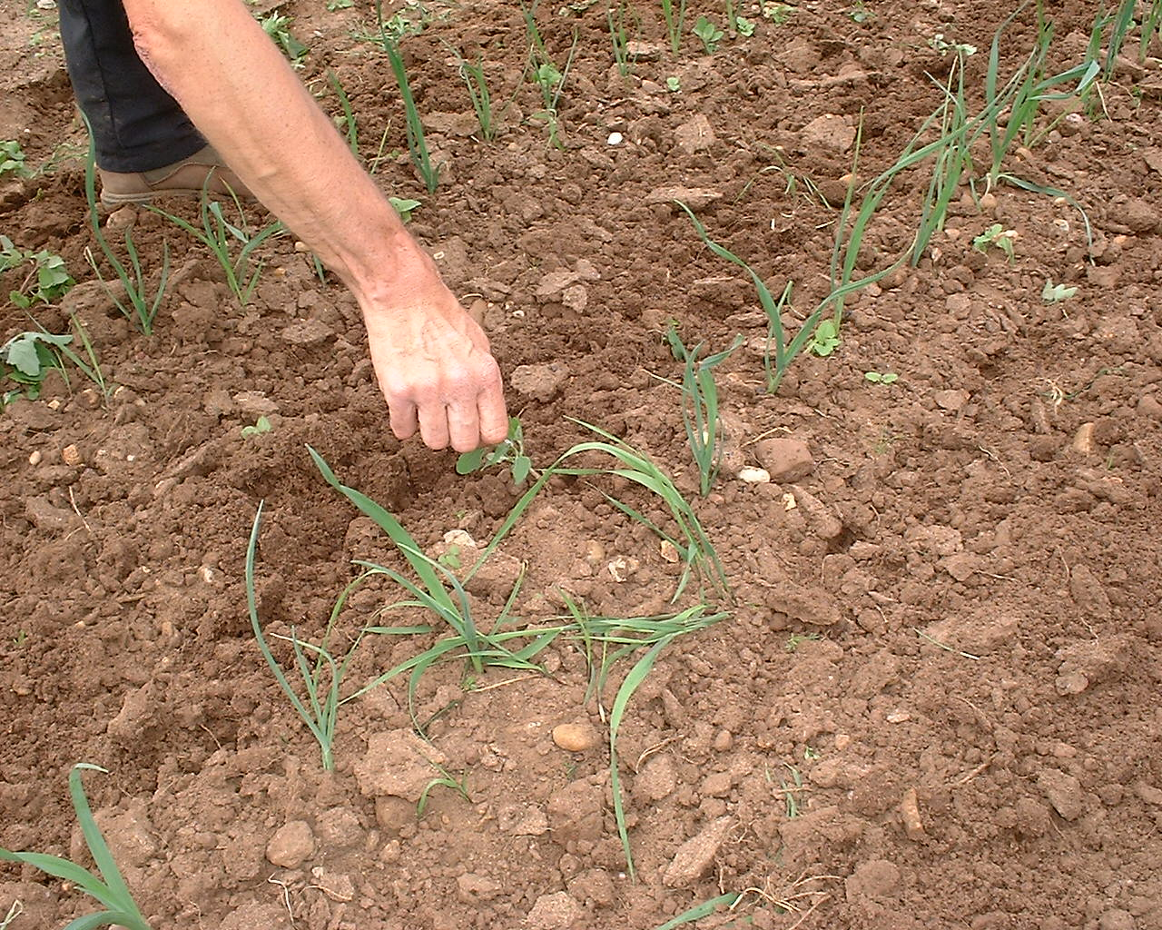

3.5 Inform organic growers of the results of the model simulations

A number of opportunities have been taken to inform growers about the model simulations, and importantly to discuss with grower’s future opportunities and practicalities for such a model within their weed control programmes.

- Presentation at the Organic Open Day for Growers at HRI Kirton. (September 2001)
- Presentation at the NIAB Organic Open Day for Growers at HDRA. Leaflets summarising the project were produced and distributed to the growers that attended. (December 2001).
- Presentation made at the Colloquium for Organic Researchers. (March 2002)
- Presentation made to Campden & Chorleywood Food Research Association. (May 2002)

4. PROJECT CONCLUSIONS

- The calibration of the model for onion was sucessful.
- The model can be used demonstrate the principle of optimal mechanical weeding times and copes well with field to field variation.
- Validation in an organic carrot trial using historical data gave a sensible prediction in advance of the optimal weeding window, which was then used in practice and tended towards higher final yields.
- Applying parameters to related crop species does appear to be a reasonable extension of the model. In particular, the use of the onion parameters for leek gave a sensible outcome for the competitive growth.
- In the final year of the project for all crops it was necessary to use a correction factor based on final harvests weights to adjust the conventionally derived model to the observations on the organic site. It is hypothesised that this empirical correction factor relates to differences in relative growth rate of the crops at the lower soil nitrogen status. The robustness of this correction factor and the hypothesis for the biological cause of the required correction could not be tested within the remit of the present project.
- The model consistently over-predicted competition (i.e. competitive growth gave much smaller crop yields than were actually observed for the majority of crops tested). This may have been a) an artefact of the atypically low weed pressure, b) over aggressive weed parameters derived from higher nitrogen status soils in conventional systems or c) oversimplified assumption of using the mean of several weed species parameters for the mixed species flora. This over prediction was notably much less for leeks which are more sensitive to competition.
- The model can be used to illustrate timing of the onset of weed competition and therefore the last date before competition and yield loss starts. However, with a seemingly less competitive weed flora and/or very competitive crop, over-complacency and leaving weeding too late can cause additional problems with the use of mechanical weeding. Similarly, harvesting difficulties and seed return may result if weeding is omitted altogether. A cut off point in terms of crop/weed growth stage beyond which mechanical weeding is ineffective could potentially be built into the model to alert to this problem. The effects of weeding on weed seed production needs to be included to allow impacts on sustainability to be evaluated. Decision support software would need to take account of availability of machinery, labour and finances.
- Presently either historical weed data collected from the field in previous years (for example as used in section 3.3) or data collected in situ during the growing season (for example as used in section 3.4) are required to drive the weed component of the growth and competition model. Using historical weed data has the advantage of being available to run simulations in advance and hence help with planning and management. However, the disadvantage is that weed populations can fluctuate considerably from year to year in terms of the relative timing and magnitude of the emergence flush and are therefore extremely dependent on for example meteorological conditions. Simulations using such historical data therefore carry greater variability and therefore risk when used in a predictive capacity. Using data collected during the growing season in question is more reliable and appropriate to that season, but has the disadvantage of only being available during the cropping season and hence has less predictive power for planning and management. Likely weed density and emergence times need to be estimated to provide realistic weed population inputs far enough in advance to have predictive power (see projects HH2011 SFV).

References quoted in Report:

Brewster, J L; Mondal, F M; Morris, G E L (1986). Bulb development in onion (Allium cepa L.) IV. Influence on yield of radiation interception, its efficiency of conversion, the duration of growth and dry-matter partitioning. Annals of Botany 58, 221-233

Finch-Savage, W. E.; Steckel, J. R. A.; Phelps, K. (1998). Germination and post-germination growth to carrot seedling emergence: predictive threshold models and sources of variation between sowing occasions. New Phytologist, Volume: 139, 505-516

Mondal, M F; Brewster, J L; Morris, G E L; Butler, H A. (1986). Bulb development in onion (Allium cepa L.) I. Effects of plant density and sowing date in field conditions. Annals of Botany 58, 187-195.

Park, S E; Benjamin, L R; Aikman, D P; Watkinson, A R. Predicting the growth interactions between plants in mixed species stands using a simple mechanistic model. Annals of Botany 87: 523-536.

Parton, W.J; Logan, J.A. (1981). A model for diurnal variation in soil and air temperature.Agricultural Meteorology 23, 205-216.

Reicosky, D C; Winkleman, L J; Baker, J M; Baker, D G. (1989). Accuracy of hourly air temperatures calculated from daily minima and maxima. Agricultural and Forest Meteorology 46, 193-209.

Please press enter

